Press
28.09.2020

cirp GmbH
Service provider for the production
of prototypes and small-run series

3D-Printing Materials Open New Horizons

3D-printing is causing a revolution in many spheres of the manufacturing technology. The basis for it are the better and more efficient materials. Selected research projects in this area are as well being funded within the framework of “Horizon 2020”, EU’s largest research and developing program ever.

As consortium partner in international research teams, the company cirp GmbH is involved in two European projects: DIMAP (Novel nanoparticle enhanced Digital Materials for 3D Printing and their application shown for the robotic and electronic industry) and MOAMMM (Multi-scale Optimisation for Additive Manufacturing of fatigue resistant shock-absorbing Metamaterials).

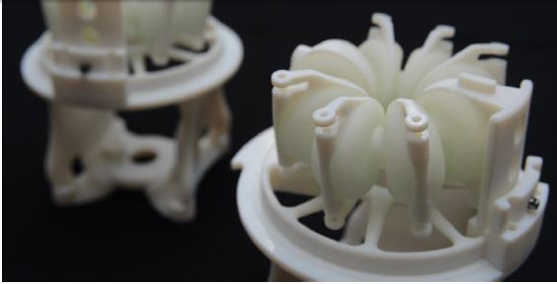
The pneumatic Festo robot actuator was printed in one step with maximum function integration.

The aim of the project DIMAP, which already ended successfully, was to expand the application area and possibilities of the multimaterial 3D printing. The research team not only succeded in redifining 3D-printing materials for the PolyJet™ technology with new property profiles, but also in enhancing them using nanotechnology. Electrically conducting inks with silver nanoparticles, thermally conductive inks with ceramic nanoparticles, foamable inks for lightweight constructions and high-performance polyamide inks were developed among other things. A specific printing architecture was created to print all these materials. Once the project ended, cirp GmbH received several “Key-innovator” distinctions by the EU Innovation Radar.

The recently started project MOAMMM, which is part of the Horizon 2020 section FET Open (Future and Emerging Markets), focuses on the simulation and production of additive metamaterials. The project aims to develop a design strategy to surpass the current ICME methodology (Integrated Computational Materials Engineering).

More particularly, a „Multi-Scale Optimisation” approach will be implemented to integrate the simulation on the different size structures in a simulation model via a “PSP Linkage” (Process, Structure, Properties). That is how the simulation of the process-relevant material properties during the 3D-printing process (micro), the simulation of the resulting properties of a material node (macro), and the material architecture of the whole component could be intertwined and directly influence each other. Regarding material development, this data-driven approach represents a completely innovative way of thinking. Demonstrators, which could be used for a wide variety of products, will be 3D-printed using highly durable and impact-resistant materials to illustrate the proposed approach. Auxetic or bi-stable material architectures can be used to improve the schockproof and safety qualities of protective equipment. Customized cushioning systems in shoes, for example, can also dynamically compensate for orthopaedic malpositioning.

For more information visit cirp.de

About cirp GmbH
Since 1994, cirp GmbH produces models, prototypes and small-run series in plastic using therefore generative procedures such as stereolithography, selective laser sintering or PolyJet. Equipped with CNC processing centers and the latest injection molding machines with a clamping force of up to 4500 Kn, our company meets the requirement to offer test-standard pieces, and often bridge the gap before the large-scale series tool. Even before finished data is available, our design department relies on modern CAD/CAM Systems and 3D scanning technologies to help its clients. As partner in various collaborative research projects, cirp GmbH is as well committed to continuously shifting and expanding the possibilities and limits from the idea to the product. (www.cirp.de)

